LETTER SIZE
Page 1
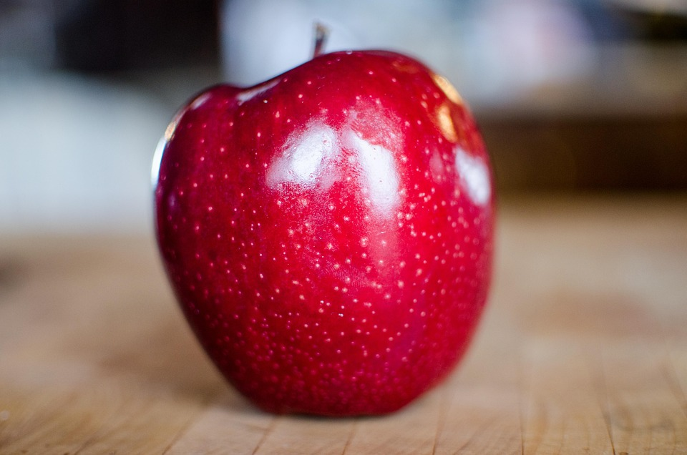

Legal Page
Page 2


This Photo by Unknown Author is licensed under CC BY-NC
Letter Page
Page 3

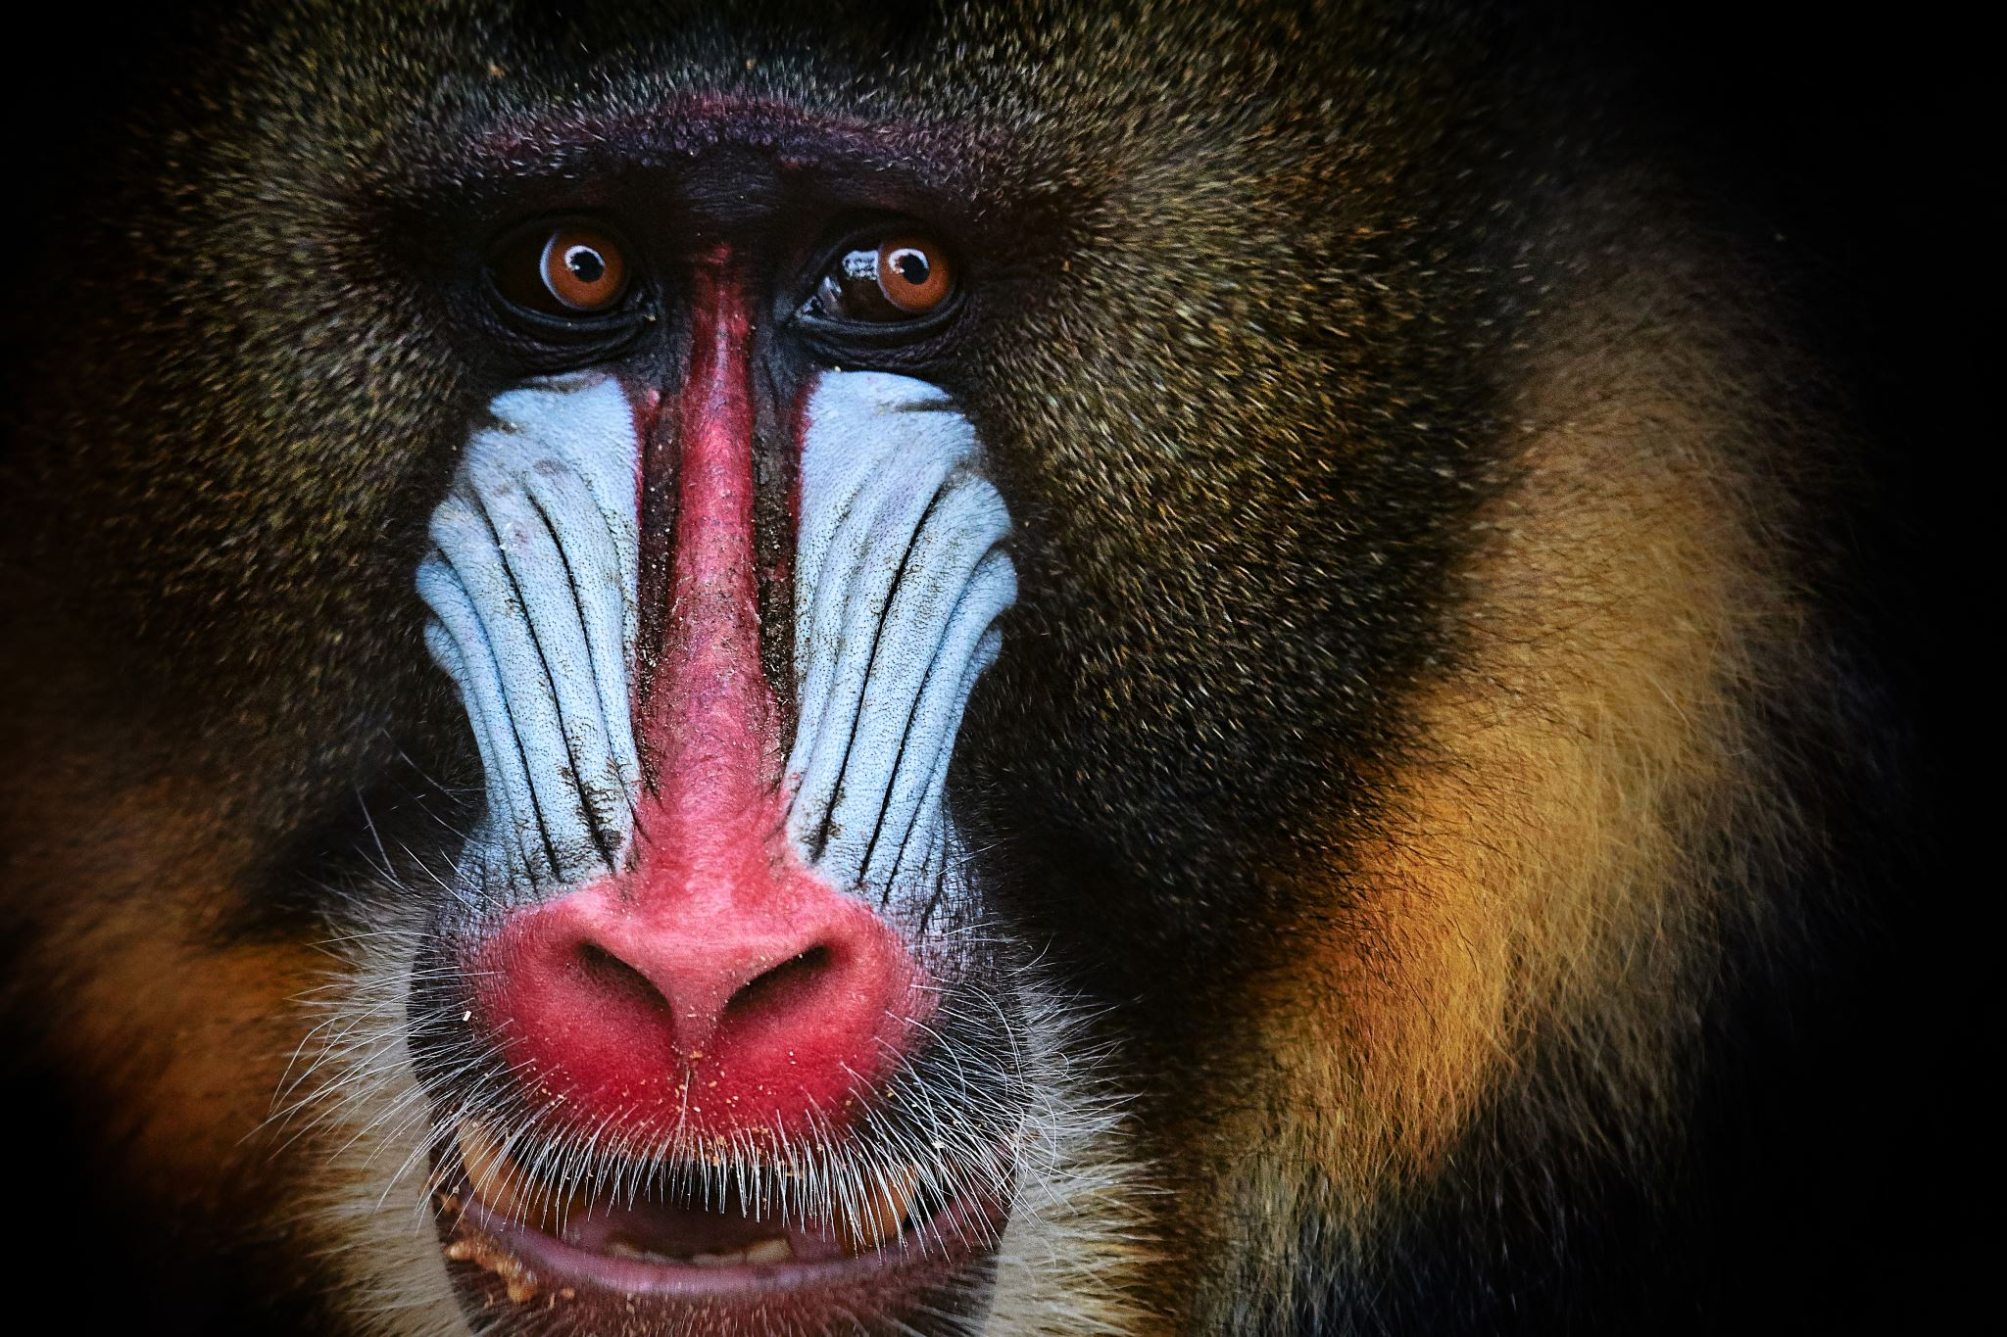
Legal Page
Page 4


